**Sleepy: A Mobile Application for Detecting REM Cycles and Snoring**

Mason Mackall, Leon Wen, Jay Yalamanchili

CMSC 23400: Mobile Computing

**Abstract** – We present Sleepy: a contactless sleep monitoring application which wakes the user based on their sleep cycles and provides snoring statistics. The sleep cycle detection utilizes the smartphone accelerometer to observe changes to the levelness of the mattress as a proxy for user movements while they sleep. It then wakes the user up within the 90-minute window before their desired wake-up time if their average aggregate acceleration surpasses 0.13 G. This ameliorates the potential feeling of grogginess from being interrupted amidst a sleep cycle. We also built a machine-learning based snoring detection system using Google’s Audioset and VGGish which separates snoring and non-snoring noises and determines how much time a user spends snoring throughout a sleep session. This achieved an accuracy of 87% against the test dataset.

**Introduction**

Poor sleeping habits can lead to chronic problems such as sleep apnea, insomnia, restless leg syndrome, and narcolepsy. Moreover, if ignored, poor sleep can manifest in increased risks of depression, heart diseases, diabetes, and more [1]. In America over 70 million people suffer from sleep disorders. Other than habitual poor sleep, a single night of inadequate sleeping conditions can be harmful. For example, 4.7% of people reported unintentionally falling asleep behind the wheel at least once in the preceding month with drowsy driving the cause of 1,550 fatalities and 40,000 nonfatal injuries annually in the US alone [2]. Given this, society should be aware of the importance of quality sleep and remedies should also be accessible. Unfortunately, sleep disorders are overwhelmingly undiagnosed and, in some circumstances, sleep deprivation is normalized [3][4]. Part of the issue is that sleep diagnosis and treatment may not be an option for most people: a polysomnogram for diagnosis costs an average of $1,000 per night [5].

Our project, Sleepy, aims to leverage the prevalence of mobile devices to help improve the sleeping habits of users. Specifically, Sleepy addresses the phenomenon of a person waking up and feeling lethargic, whether or not they have had sufficient hours of sleep. This is often attributed to waking up during sleep cycles. The program uses a smartphone’s accelerometer to collect information about the user’s sleeping movements to detect sleep cycle phases and identify rapid eye movement (REM) and non-rapid eye movement (non-REM) sleep. Users can select a time before when they wish to wake up by and Sleepy will sound the alarm at the end of the last sleep cycle before the pre-determined time. Another included feature is Sleepy can also record audio data to determine the percentage of time during sleep a user is snoring. Snoring is caused by obstructed breathing while sleeping and can be an indicator of sleep issues. These two features are not an all-encompassing solution for sleep disorders but are meant to ameliorate feelings of sleep-deprivation as well as help users identify potential sleep problems.

**Background**

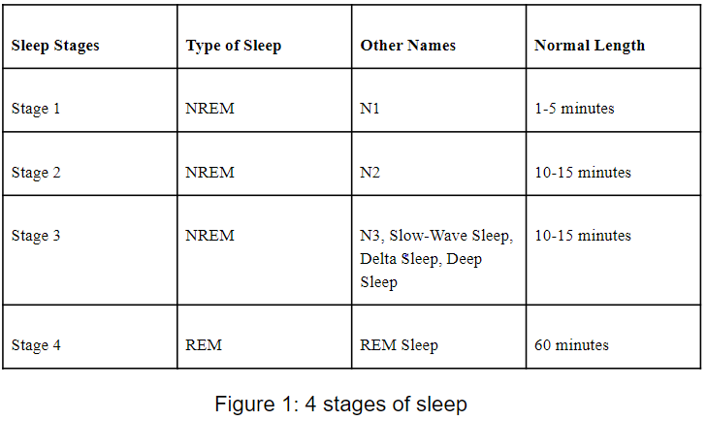

A sleep cycle can be broken down into four stages; three leading stages which form non-REM sleep and a last one for REM sleep [6]. N1 is the “dozing off” stage when the body and brain activities begin to slow with periods of brief movements (twitches) but the body has yet to fully relax.

Although this period only lasts 1-5 minutes, a person is extremely susceptible to being woken up during this stage. N2 is characterized by relaxed muscles, slowed breathing and heart rate, and a drop in body temperature. This typically lasts 10 - 15 minutes and get longer as you sleep. The body and brain continue to relax further in N3, which is also known as “deep sleep” since it is difficult to wake someone up in this phase. Opposite of N2, N3 becomes shorter as you sleep and lasts 15-10 minutes. This stage is important for restorative sleep and strengthening the immune system and other key body processes. Lastly, the body enters REM and atonia, a temporary paralysis of the muscles, excluding the respiratory and eye muscles.

Brain activity achieve levels similar to those of when a person is awake, and the eyes are moving quickly beneath the eyelids. It is during this period where the most vivid dreams occur. REM durations lengthen as sleep becomes longer and can last around an hour at the end of a full night of sleep. The total length of a sleep cycle depends on the duration of sleep but on average, a single cycle lasts 90 minutes.

Although most cases of snoring are benign, continuous snoring for long periods more than three nights a week can be signs of existent sleep problems. Snoring originates from the vibration of throat tissues that are constricted when we breathe. Obstructive sleep apnea is associated with snoring and can lead to daytime drowsiness as well as increased blood pressure and risk of cardiovascular issues. A key characteristic of obstructive sleep apnea is a series of prolonged loud snoring followed by a lapse in breath when the airway gets blocked or collapsed. Most people do not have witnesses overseeing their sleep and victims of obstructive sleep apnea tend to be unaware of their condition.

**Solution**

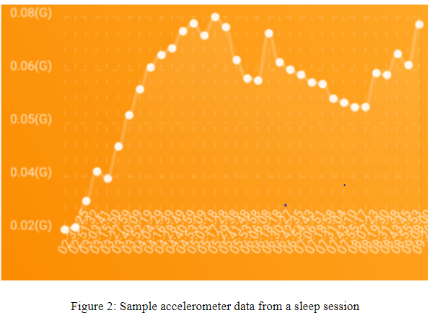

Sleepy is a non-contact sleep monitoring application which observes a user’s sleep movements through accelerometer data. Prior to sleeping, users provide their latest possible wake up time and place the phone on their bed plugged in to a power source. The phone’s accelerometer will sense minute depressions and swells of the bed surface caused by the user’s movements as they enter and exit various phases of the sleep cycle. A data point is collected every second and it records $G =\sqrt{x^{2}+y^{2}+z^{2}}$. G is g-force or the magnitude of the acceleration and the x, y, and z represent the accelerometer measurements of the device’s roll, pitch, and yaw respectively. Moments of low G indicate deep sleep or REM sleep where the body’s muscles are relaxed; conversely, moments of high G reflect the body exiting the REM phase and beginning a new phase of N1 where the body involuntarily twitches. It is generally better for a person to be woken up during N1 and N2 as apposed to N3 and N4 to avoid the feeling of lethargy from being interrupted in deep sleep. In the current phase of Sleepy, the algorithm activates the alarm within the last 90-minute window prior to the user’s predetermined wake-up time if the 5-minute moving average is above 0.13 G. To avoid unintentional shocks to G by the user bumping into the device, we use the Sigmoid function to smooth measurements. The function is as follows: $S_{g}=\frac{0.4}{1+ ε^{-10g}}-0.2$; where *t* is time and ε is Euler’s number. Under this Sigmoid transformation, $f\left(g\right)=g$ for small values of *g* but $f\left(g\right)$ approaches 0.2 for large values of *g*.

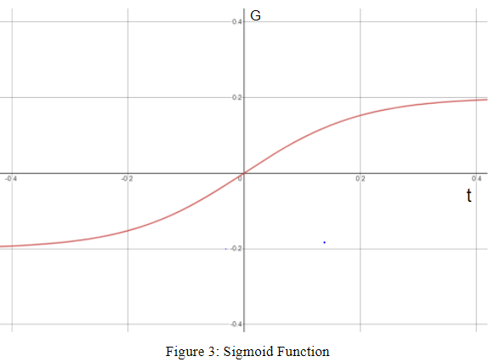

After waking up the user can choose to store the current session on their device and review their previous sleep sessions to observe trends in their sleeping habits. High frequencies of restless sleep as represented by G could be motivation to seek medical advice on potential sleep problems and help patients vocalize specific problems with their sleep.

Alongside the REM detection feature is a snoring model created using Google Audioset and VGGish for separating snoring and non-snoring sleep sounds. Google Audioset extracts 128 features from audio and is trained with Deep CNN on millions of audio clips whereas VGGish is a pretrained Convolutional Neural Network for audio classification. Users who submit audio clips recorded throughout their sleep sessions can have their sample tested to know the amount of time they had spent snoring throughout their sleep.

**Evaluation**

Sleepy has been tested on the IPhone, Google Pixel 2, and Google Pixel 3. We have tested the sensitivity on a range of surfaces such as mattresses, couches, floors, and table tops with motions ranging from body rolls, aggressive taps, to light taps. The accelerometer data collected shows that these phone models are extremely sensitive and the application is able to capture this. Throughout testing, we conducted ~50 short trials and 9 trials of overnight collection. Collection intervals for short periods of time was set for once per millisecond while overnight trials under normal settings was set to once per second. Average length for a long trial was 6 hours and 27 minutes. Sleepy stopped recording once due to the display screen turning off.

Sleepy’s current algorithm uses a fixed threshold of G = 0.13 to determine when to trigger the alarm. A hard-coded threshold does not account for variance in mattress elasticities which would impact the recorded G from the same motions on different beds. Neither does it factor in individual’s unique range of motions throughout their sleep cycles since some users may have a tighter range of movements as observed within our own three-member development team. As such, some may easily trigger an average of 0.13 G while others may never reach the threshold. At the same time, when Sleepy calculates number of sleep cycles detected, we use 90-minute intervals based on the average length; however, as aforementioned, sleep phases vary in length depending on length of sleep and individual traits. Given more time, we would have models which incorporate a user’s historical sleep data into our predictions. It would consider how a user’s range of movements change throughout the night over many nights to determine the threshold at which they break out of REM sleep.

We also ran into issues during the testing phase for Sleepy surrounding Expo Go and phone models. Expo Go is a developer tool used for running mobile applications with interactive gestures and graphics. We had noticed that Google Pixel users always witnessed a “Component Exception” error when loading a new version of the application for the first time. Although this is resolved automatically after rebooting it is a negative first impression of the application. In addition, because the application must be running overnight in most cases and it cannot run in the background, it steadily consumes a lot of battery life and the device is recommended to be plugged in throughout the night. Even then, the prolonged use of the phone display will wear away at the useful life expectancy of the device. Another issue is with the load required for generating and storing accelerometer data for some smartphones. For testing, we increased the frequency of measurement to one every millisecond and this caused Sleepy running on Google Pixel 2 to crash after storing roughly 50,000 measurements. Applied to the working one per second measurements, this is slightly less than 14 hours of sleep. Even though it is generally not recommended to sleep 14 hours at a time, smartphones less sophisticated than a Google Pixel 2 may only be able to handle fewer hours of recording. An alternative hypothesis is that some phones cannot meet the demands of 1000 accelerometer measurements every second. In this case, we have to keep this in mind if we ever decide to change the rate.

Our snoring detection model was trained against a selection of 300 snoring and non-snoring files from Google Audioset cut into 1 second segments and achieved an accuracy of 87%. Errors committed were roughly equally split between false positives and false negatives.

**Conclusion**

In this paper we presented the design, implementation, and evaluation of Sleepy, a non-contact sleep monitoring application. The primary feature is a movement detector which leverages smartphone accelerometers and wakens users at the end of sleep cycles to prevent daytime drowsiness. In addition, we have created a model which detects user snoring from audio clips and determines how much time is spent snoring during each sleep session.

Potential additions to improve Sleepy would be to implement the audio recording and diagnosis into the application as well as enable the model to detect potential obstructive sleep apnea. This would require Sleepy to detect collapsed airways through abrupt silences following a period of loud snoring. There are also other front and back-end developments which would make Sleepy more accessible to users with older phone models or Android phones.

**References**

[1] CDC. https://www.cdc.gov/sleep/data_statistics.html

[2] Sleep Association. https://www.sleepassociation.org/about-sleep/sleep-statistics/

[3] Sleep Health. https://www.sleephealth.org/sleep-health/the-state-of-sleephealth-in-america/

[4] Crutchfield, Rashida M., Andrea Carpena, Tahirah N. McCloyn, and Jennifer Maguire. "The starving student narrative: How normalizing deprivation reinforces basic need insecurity in higher education." *Families in Society* 101, no. 3 (2020): 409-421.

[5] Very Well Health. https://www.verywellhealth.com/what-to-expect-in-a-sleep-study-3015121#:~:text=Cost%20and%20Health%20Insurance&text=Overnight%20polysomnograms%20may%20cost%20from,the%20majority%20of%20this%20expense.

[6] Carskadon, Mary A., and William C. Dement. "Normal human sleep: an overview." *Principles and practice of sleep medicine* 4 (2005): 13-23.